Hotel Booking

***REQUIREMENT:***

**This Requirement is about Raj Travels website. It is used to Book Hotels in India and also internationally. The below Screen will help you to book a hotel by entering the Country, City, Check in and Checkout dates, Number of rooms, Adults and children details.**

**Fields:**

* **Location - Radio Button (India or International) and it is a Mandatory Field.**
* **Country- List box. It is a Mandatory Field.**

1. **Current values in database “India, USA, UK”.**

* **City – List box. It is a Mandatory Field.**

1. **The current values in database.**

* **India - “Delhi”, “Mumbai”, “Calcutta”, “Chennai”.**
* **USA – “New York”, “San Jose”, “New Jersey”, “Niagra”**
* **UK – “ England”, “Scotland”, “Leeds”, “Glasgow”.**
* **Note:**

1. **If the Radio Button under “Book your hotel” is selected as “India” then, only List Box 2(City) should be displayed. The List Box 1, “Country” should be Inactive.**
2. **If Radio Button under “Book your hotel” is selected as “International”, then both the list boxes “Country” and “City” should be Active.**

* **Check In – List box. It is a Mandatory Field.**

1. **The valid Data Format is DDMONYYYY.**

* **Check Out – List box. It is a Mandatory Field.**

1. **The valid Data Format is DDMONYYYY.**
2. **Note: The “Check Out” date should be >= to the “Check In” date**

* **Nationality - List Box. Current Values in database – “Indian”, “Others”**
* **Rooms - List box with Data Range 1-6.**

1. **Room<#> - Label.  The Room Number # should be displayed based on the number selected in ROOMS List box.**
2. **The number of rows should also coincide with the number of Rooms selected. The same set of List Box should be displayed for each row.**
3. **If the “Rooms” List Box has value as “2”, then 2 rows.**
4. **Each Row should have List Box – “Adults’ and “Children”.**

* **Adults (above 12 years) - List Box. It is a Mandatory Field.**

1. **Valid Data Range – 1-2.**

* **Children (below 12 years) - List Box.**

1. **Valid Data Range– 0-4.**

* **Search – Button**

1. **After filling all the mandatory details and on clicking “Search” button, the application validates the data.**
2. **If valid, the application displays the required details in the next screen.**
3. **If the data is invalid, the application displays appropriate error message in the next screen.**

**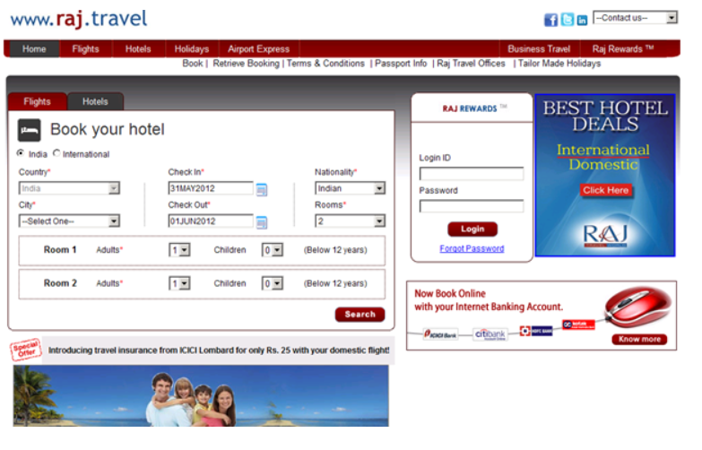 UI Screenshot:**